InDetail

**NYSCRF Bridge Logistics Develop to Core Fund**

An Industrial Development Fund-of-One

October 2024

Table of Contents

Executive Summary 1

Overview 1

Comparative Advantages 2

Potential Issues and Concerns 3

Strategy 5

Overview 5

Pipeline 6

Leverage 6

Investment guidelines 6

Sponsor 6

Overview 6

Bridge Logistics Properties 8

Turnover/Compensation/Retention 8

Investor Base 9

Compliance / Litigation Disclosures 9

Environmental and Social and Governance Policies and Practices 9

Summary 9

Operational Due Diligence 10

Summary 10

INVESTMENT PROCESS 11

Summary 11

Investment Committee 11

Affiliate Fees 11

Exclusivity/Allocations 12

Hedging 12

Valuations 12

FUND STRUCTURE 12

Key Terms 13

fees and Distributions 13

Fee Analysis 14

PERFORMANCE (as Of March 31, 2024) 15

Logistics VAlue Ventures 15

BLV I - Vintage Peer Comparison 16

BLV I – Index Comparison 16

Other Development Activity 17

**Exhibit A: Pipeline Exhibit H: Strategy Allocation Guidelines**

**Exhibit B: Bridge Corporate Structure Chart Exhibit I: BLV I Asset Management Summary**

**Exhibit c: Bridge Organizational Chart Exhibit J: BLV I Deal-by-Deal Performance Info**

**Exhibit d: BLP Organizational Info Exhibit K: BLP Development Transactions**

**Exhibit E: Senior Personnel Biographies Appendix: Rating Rationale**

**Exhibit F: Project Approval Process**

**Exhibit G: Affiliate Fee Schedule**

# Executive Summary

## Overview

|  |  |  |
| --- | --- | --- |
| Review Date | Rating | Prior Fund Rating |
| October 2024 | **Buy** | N/A |

Bridge Logistics Develop to Core Fund (the “Fund”) is being established by Bridge Logistics Properties Fund Manager LLC (“BLP” or the “Sponsor”), a subsidiary of Bridge Investment Group Holdings LLC (“Bridge”) as a single investor Fund managed on behalf of NYSCRF to pursue industrial development. The $600 million Fund will target returns in excess of 15% net over an initial eight-year term. Formal operating documents have not been finalized and Townsend’s analysis is limited to the available information as currently understood through discussion with BLP, NYSCRF staff, and review of the latest Framework Term Sheet.

*Strategy:* The Fund will serve primarily to capitalize BLP development dealflow with parameters that fit outside of Bridge’s finite-life flagship fund series. This includes larger projects presenting greater concentration risk to a closed-end fund, projects with a longer or more complex entitlement process, and projects with multi-phase execution and construction timelines less appropriate for a typical closed-end fund. Bridge will target opportunities where untrended stabilized yield-on-cost can be underwritten to 75-150 bps premiums to prevailing market cap rates. Bridge focuses on a defined list of “U.S. Global Gateway” and “Regional Prime Growth” markets and will pursue relatively infill sites with reduced potential for competitive supply. The Fund will develop assets over a 2-3 year development phase and transition them into a core hold phase with sale at NYSCRF’s discretion.

*Sponsor:*

|  |  |  |  |
| --- | --- | --- | --- |
| **HQ Location** | Salt Lake City, UT | **Parent** | Bridge Investment Group |
| **Ownership** | Public (NYSE: BRDG) | **Founded** | 2009 (BLP in 2021) |
| **Staff Members (BLP)** | 34 | **Gross AUM (June 30, 2024)** | $49B ($983M Logistics) |

***Track Record (as of 3/31/2024)***



*Portfolio Characteristics:*

|  |  |  |  |
| --- | --- | --- | --- |
| **Vehicle Structure** | Fund-of-One | **Risk Category** | Opportunistic held to Core |
| **Expected Fund Size** | $600 million | **Sponsor Commitment** | 2% of capital commitments |
| **Commitment Period** | 3 years | **Fund Term** | 8 years |
| **Avg. Investment Size** | $120 million total cost | **Typical Business Plan** | 3-5 years |
| *Fees:*  **Management Fee** | .35% on GAV | **Incentive Fee Waterfall** | 9% preferred return  80% LP / 20% GP until 13% 2nd pref  70% LP / 30% GP thereafter |

*Status:* The Fund will be reviewed at the November NYSRCF REAC and begin investing based on NYSCRF’s closing timeline.

DISCLOSURE

Open-Items

* Disclosure
* Comparative Advantages
  + Portfolio Summary, embedded Value?, fund projections
  + Market Commentary / Entry Point / Advantages of the Focus Segment
  + What else would we highlight?

## Comparative Advantages

1. Enhanced Governance

The vehicle offers NYSCRF enhanced discretion and unique approval rights not available in commingled funds:

* Investment Approvals: Project approval (including three approval stages prior to pursuit, land closing, and vertical construction) and sale or disposition of projects after stabilization or 24 months from the issuance of certificate of occupancy.
* Asset Management Items: Approval of annual operating budgets, capital contributions over amounts in approved budgets, financing and material modifications to financing structures outside of pre-defined limits, rezoning or subdivision of approved projects, institution or settlement of material litigation, selection and contracts of initial and future leasing agents and property managers, approval of related party agreements and other items subject to potential conflict of interest.
* Fund Structure Items: Merger of the Fund with another entity, admission of additional partners, approval of changing tax items and status, fund insurance items, liquidation or bankruptcy of the partnership.

1. Total Expense Load

The fee structure for the offering is favorable relative to alternatives in the closed-end fund space, which would be the primary alternative structure for pursuing a pureplay development strategy. There is effectively no asset management fee during the development phase; Bridge will only collect a development management fee, which would otherwise be payable to a third party. During the stabilized hold phase, the asset management fee of .35% on GAV (roughly 70 bps on NAV at the Fund’s 50% refinance assumption) is favorable relative to core OECF alternatives. The incentive structure (mostly by way having no GP catch-up provision) is favorable relative to closed-end commingled fund standards until the Fund achieves material outperformance. Comparative analysis is detailed in the *Fund Structure* section of this report. It is also worth noting that the Sponsor’s vertically integrated business model eliminates the need for a double promote associated with executing through a JV development partner, saving, as a broad estimate, 200 bps from property level to gross IRR with potentially much greater savings on successful deals. JV structures would be a common execution for development exposure through diversified opportunistic commingled funds or a minority allocation within core/core-plus commingled funds.

1. Experience and Proven Execution

Although the platform is relatively new, Townsend has direct first-hand experience into the quality of the platform build-out as a foundational investor in the firm’s first two flagship value-add funds (“BLV I” and “BLV II”).

The Bridge team is comprised of well-known industry participants with strong relationships to key owners, developers, brokers, and tenants across a global network. Its senior leadership consists of highly experienced professionals with deep logistics expertise and experience with platform build outs.

* Jay Cornforth – CEO and Co-CIO of Bridge Logistics Properties with 27 years of experience
  + Brookfield (2013-2020): Managing Partner and Global Head of Logistics
  + IDI Logistics (2013-2016): CEO overseeing and leading the acquisition and rebranding of IDI Gazeley
  + Prologis (2011-2013): President, East Region overseeing 91 million square feet
  + AMB (2003-2011): President through merger of AMB and Prologis in 2011
  + Cabot (1998-2003): SVP overseeing development nationally
* Brian Gagne – Co-CIO of Bridge Logistics Properties with 18 years of experience
  + Brookfield (2017-2020): Head of U.S. Industrial; acquisition/development lead
  + IDI Gazeley (2015-2017): Head of Western U.S. Industrial
  + KTR (2005-2015): Partner and Acquisition Team Leader; opened company’s West Coast office in 2007
* Jay and Brian have served in critical capacities establishing new brands and platforms (including building the Brookfield industrial team twice) while successfully executing on a wide range of industrial investment strategies. Townsend conducted numerous reference checks on both Jay and Brian with current and former employees of Brookfield. All reference checks came back extremely positive.

Bridge has fully built out the platform, which now totals 34 employees, successfully assembling a highly skilled and experienced cohesive roster of talent. The team has displayed impressive execution capabilities over a three-year period as an active investor, deploying a high-tempo transaction strategy that leverages its strong relationships across its target Markets to source ~85-90% of deals via off-market channels and selectively marketed situations, thereby mitigating pricing competition and benefiting the acquisition basis of the initial BLP Fund ventures. Venture I has accumulated a portfolio of 32 functional infill logistics assets and sites totaling ~2.9M sf (~3.2M sf inclusive of planned development) in a short period of time. Bridge has successfully completed over 1.3M sf of leasing since the fund’s inception at a premium to underwritten rent levels. Townsend’s points of contact have noted Bridge’s ability to adapt to rapidly changing economic conditions, applying a more discerning lens to new investments, and only pursuing opportunities that prove to be very durable when sensitizing for more conservative leasing and exit assumptions. Townsend would note that BLP has been consistently responsive to investor needs and continues to foster a highly collaborative and communicative relationship.

1. Potentially Attractive Entry Point

* Diminished Supply: Per Green Street, supply completions remain elevated but should begin to trend lower due to declining development starts since late 2022. Completions, particularly in higher barrier coastal markets, are expected to dip below long-term pre-pandemic trend in 2025 and 2026, providing a potentially more attractive delivery window for development starts early in the Fund’s life.
* Financing Availability: Debt capital markets have contributed to a decline in competitive supply. Traditional construction lending sources, particularly banks, have limited financing to a smaller list of trusted relationships and reduced proceeds to lower LTC levels. This limits supply from more marginal private merchant developers and benefits institutional sponsors with strong lender connections. It is a structural change to the lending environment that potentially extends the window described above.
* Land Repricing: Townend’s discussions with developers and other industry participants anecdotally confirm Bridge’s view that land pricing has declined in the range of 30-50% relative to 2022 peaks. Although volume of trades have declined (holders of potential development sites are typically unlevered and therefore able to wait out periods of pricing softness) the pricing on active trades has helped maintain appropriate yields in the face of increased construction costs, higher cost of debt, and higher required buyer yields at exit.

## Potential Issues and Concerns

1. Lack of Realized Track Record

Although the senior Principals have a high level of experience, the platform as currently constituted has yet to produce meaningful realizations. Bridge Logistics Venture I is the platform’s first fund product and has a portfolio of 32 assets acquired from late 2021 through 2023 and has not produced any realizations. Generally speaking, the industrial sector has many options to invest through sponsors with more substantial performance history.

**Discussion:** At this stage in the platform’s life, the level of realizations is not unusual. The BLV I portfolio is still in the value creation phase and the asset size generally benefits from exit as a portfolio or through sub-portfolios, limiting the relevance of early one-off sales. Given the vintage, the Manager did not benefit from the period of abnormally high liquidity in the space during late 2020 and 2021 that generated quick realizations for early-stage sponsors only slightly older than BLP. The-mark-to-market figures are a product of increased exit cap rate assumptions consistent across the market in the wake of the rate hike in 2022; BLV I exit cap rates have been adjusted from an original underwritten aggregate of 4.5% to a more conservative 5.4%. As mentioned previously, execution at the property level has been ahead of underwriting and the fund projects a life-of-fund IRR moderately below original target at 10.3% net. Bridge’s status as an early-stage manager also contributes to their willingness to structure a custom product with NYSCRF rather than launch a more broadly marketed commingled fund or club and the lack of realizations should be weighed against the benefits provided by this custom vehicle.

1. Higher Risk Strategy

The Fund will only pursue development. When reviewing non-core commingled funds, it’s rare to see vehicles with 100% development exposure. This is generally considered a higher risk strategy and limited to 30-40% allocations within most closed-end non-core vehicles. Additionally, Bridge is willing to take on entitlement risk in some instances. Common practice for development in closed-end vehicles is to pursue development only on pre-entitled sites. The entitlement process can lead to project delays related to local approvals and unforeseen local infrastructure requirements, contribute to dead deal costs and/or IRR drag from initial capital outlays pre-construction, or have negative effects on land value if expected entitlements are ultimately not achieved.

**Discussion:** Consistent with standard institutional practice, development risks associated with cost overruns are controlled with GMAX contracts and BLP will further fund certain overruns not covered by contracts via its development fee. In relation to the final budget within the GMAX Contract, controllable cost overruns not covered by the contractors and/or its bonds, insurance or applicable cost savings and contingencies (“Covered Cost Overruns”[1]) would be funded 100% by BLP up to an amount equal to 50% of BLP’s Development Fee for the applicable project, and thereafter pro rata by BLP/NYSCRF.

From a timing perspective, industrial development is generally at the lower end of the risk spectrum in terms of total time to delivery and construction complexity. The fund-of-one structure alleviates some of the urgency with respect to liquidity and capital management restrictions placed on finite-life vehicles with a commingled LP base. Development exposure can be managed by NYSCRF in the context of its own portfolio.

Entitlement risk is often manageable through options or contingencies with the seller around successful land entitlement, limiting capital outlay to pursuit costs representing relatively small amounts of the land basis. Bridge will share pursuit costs on a 50/50 ratio from the project’s conceptual approval to be “trued up” at land closing, limiting initial outlays by NYSCRF. Taking on additional potential entitlement risk is at times crucial to Bridge’s preference toward infill site selection in supply constrained markets and ultimately can provide access to sites that are less risky from a leasing and competitive supply standpoint. Bridge states that premiums of upwards of 100 bps on YOC can be achieved by taking manageable and targeted entitlement risks while typically still structuring seller contingencies. From a J-curve perspective, potential dead deal costs are also offset by the lack of an asset management fee during the construction phase.

1. Incentive Structure

The Fund’s incentive structure is calculated and distributed on a deal-by-deal basis, resembling a joint venture structure more than a typical fund structure. Promote allocation/distributions are crystalized based on an assumed valuation of each asset at stabilization and may not reflect actual ultimate sales price. There is potential for conflict in arriving at mark-to-market valuations. In the event of a wide dispersion of returns, a deal-by-deal promote could cause higher than expected gross-to-net leakage relative to a pooled promote. There is no portfolio-wide make-whole ensuring that the Sponsor is limited to any specific percentage of total profit. This would be standard expected practice in commingled funds with interim promote distributions, which are a small minority of closed-end funds in general. The Fund does have a clawback mechanism, but this only provides for a minimum portfolio-wide IRR of 9%. For assets being rolled over into the Fund’s longer term hold portfolio, this also creates a cashflow question in terms of distributing the 50% portion of accrued carry which the GP is entitled to receive in cash (the remainder being rolled into the deal as GP equity).

**Discussion:** The Fund’s final venture documents will provide for a third-party appraisal process at stabilization and have language around dispute resolution, expected to provide for multiple appraisals chosen by each party if necessary to arrive at a consensus valuation. While some suboptimal possibilities remain, and Townsend cannot opine on a written outline of the process at this time, the process as generally understood is typical for vehicles with a development phase and core rollover. The clawback provision could be further enhanced by requiring clawback amounts to the extent the total GP share of profit exceeds 30% (the final promote tier). In terms of cash distribution of the earned promote, asset refinancing proceeds are expected to generate the required cash in most cases[2]. The Partnership will not be required to fund capital in any instance to pay the realized incentive, though the GP would be entitled to a 9% interest rate per annum on unpaid amounts after 30 days.

# Strategy

## Overview

The Fund will focus on ground-up development of larger bulk industrial, industrial distribution facilities, or large multi-phase business parks for a long-term hold, targeting a net IRR in excess of 15% (requiring gross IRRs of 17-19%) during its development phase, then transitioning assets into a long-term hold phase expected to produce levered core-like returns of 9-11% net. This can be thought of as a minimum return threshold; the current fund model assumes gross development phase IRR of 26.5% and stabilized hold period IRR of 11.5%, blending to an 18.9% gross IRR and 16.6% net IRR over the life of the fund.

* Sites typically will have industrial zoning with some degree of entitlement and permitting risk taken on. Bridge seeks to avoid situations with discretionary city/county approvals around land use and would require closing contingencies or options with the seller to take on this level of entitlement risk.
* Bridge’s development targets are typically infill sites located near major transportation infrastructure.
* The Fund will target assets in U.S. markets with population density, trade infrastructure and high barriers to new supply. Bridge divides these into two categories:
  + U.S. Global Gateway: New York, Northern New Jersey, Southern California, South Florida, DFW, SF Bay Area, Atlanta.
  + Regional Prime Growth: Seattle, Denver, Portland, Austin, Boston, Houston.
* The Fund will pursue projects with land purchase price of $50 million or above. Total project capitalization is expected to be at or above $120 million. Land price as a percent of total budgeted capitalization averages an estimated 39% across Bridge’s focus markets.
* Development will typically focus on bulk industrial and distribution facilities of minimum 500k square feet and projects as large as 4 million total square feet across multiple buildings/phases. The Fund may also develop smaller and/or quicker to market facilities where the BLP value fund series has limited capacity.
* The Fund will target development opportunities where assets can be delivered with stabilized yield-on-cost of 75-150 basis points above prevailing spot cap rates.
  + Current stabilized yields are being underwritten from 7% to 10% depending on market.
  + Exit cap rate assumptions are generally in the high 5% to 6% range.
* Development timelines vary but ranges can be generalized as follows, with partially overlapping phases pursuant to a 3–5-year underwritten hold to stabilization on most prospective investments:
  + 3–9-month sourcing and diligence period (often predates the Fund’s involvement)
  + 6–12-month entitlement period as necessary
  + 10–12-month vertical construction period
  + Plus additional 10-12 month vertical phases

## Pipeline

* Bridge has identified several near-term development opportunities fitting the fund’s investment profile that may represent initial opportunities shown to NYSCRF. These are summarized in **Exhibit A.**
* A broader summary of all development activity in diligence across the platform is also included.

## Leverage

* Bridge will utilize non-recourse construction loans for each approved project at a loan-to-cost of 60% or on terms and conditions acceptable to NYSCRF. It is expected that the Fund will provide completion guarantees and neither NYSCRF or BLP would provide any lender guarantees[3].
* Upon stabilization, the Fund will obtain a non-recourse permanent loan for each project with an LTV under 55%, targeting an aggregate portfolio LTV of under 50%.
* The Fund model assumes construction financing at S+385 and 60% LTC. The refi assumption is 50% LTV at 200 bps over estimated ten-year UST.

## Investment guidelines

The level of NYSCRF discretion makes traditional fund investment guidelines less relevant. Generally, the investment strategy will be defined as targeting U.S. industrial assets where untrended return on cost is 75-150 basis points above current core acquisition cap rates. Certain Excluded Projects are not required to be shown to the Fund which include projects subject to an existing right of first offer in favor of existing funds/joint ventures sponsored by BLP. BLP would in turn be restricted from developing any ground-up logistics properties within a 3-mile radius of a non-stabilized Approved Project in the Fund unless first offered to the Fund.

# Sponsor

## Overview

Background: Bridge origins trace back to 1990 to a number of people working together in real estate but at different/predecessor firms. At the time, former S&L employee Dan Stanger was doing S&L REO workouts through his independent company, and former Lucent executive Christian Young was raising friends & family money to capitalize Mr. Stanger’s investing. They formed a company called CDS Investments in 1997 to continue investing opportunistically in distressed real estate situations more broadly. In 1999 they added two equity partners, property manager Russell Minnick who formed an affiliate called Bridge Property Management Co, and Brad Andrus who formed a commercial mortgage banking affiliate. Richard Stayner (property management) and Kevin Anderson (accounting/admin) were added as partners and the business merged with Dean Allara from San Francisco who had a similar informal workout/investment business. In 2001 the seven partners renamed themselves Bridge Partners. Bridge Partners initially acted as an operating partner in multiple property types for syndicated HNW capital. Over time the firm joint ventured with institutional capital partners including Angelo Gordon, Apollo Real Estate, Buchanan Street Partners, Citigroup, CV Starr & Co, and PCCP.

In 2009 they entered the fund sponsorship business investing in apartments and office through their own funds called Real Estate Opportunity Capital (“ROC”) Funds I and II. In 2013, the partners started an expansion into thematic property types that would support dedicated fund series; dropping the “ROC” part of their fund names, calling themselves Bridge. Bridge formed 9 business verticals by property type, often lifting out whole management teams and PMs to head each fund series. In 2011, the principals formed Bridge Multifamily Fund Manager LLC (formerly Bridge Investment Group Partners LLC) as an SEC registered investment adviser. The entity was renamed to Bridge Investment Group LLC and later, Bridge Investment Group Holdings LLC. In July 2021, Bridge completed an initial public offering of its ultimate parent company, Bridge Investment Group Holdings Inc., of its shares on the New York Stock Exchange (NYSE: BRDG).

* Bridge employees and legacy partners continue to own a majority of the firm. The public float represents approximately 28% of ownership. Robert Morse is the largest individual owner at 27%. The remaining 45% is held by various bridge principals and legacy owners each representing less than 10% of the total company. Bridge’s corporate structure chart is included in **Exhibit B.**
* Jonathan Slager serves as CEO of Bridge Investment Group, Robert Morse as Executive Chairman, and Adam O’Farrell as COO. These professionals, along with Vice Chairman Dean Allara, comprise the Bridge Investment Group Holdings Executive Directors, who together with three independent directors comprise the company’s Board of Directors. Bridge’s organizational chart is included in **Exhibit C.**
* Bridge employs over 2200 employees in 14 offices and onsite locations in the U.S., with international offices in Luxembourg and South Korea. The firm’s corporate headquarters is in Salt Lake City, Utah.
* The firm’s AUM totals $49 billion gross in 12 investment verticals.



## Bridge Logistics Properties

Bridge Logistics Properties is a subsidiary of Bridge Investment Group founded in 2021 to expand Bridge’s existing sector footprint by building and growing a vertically integrated sector-focused logistics platform. Bridge hired Jay Cornforth and Brian Gagne, industry veterans most recently holding key positions within Brookfield’s logistics investment platform with previous working history at IDI Gazeley. The team has been built out to total 34 dedicated professionals in offices across the U.S. including Newport Beach, Dallas, New Jersey, Atlanta, and Miami.

* Ownership: 60% by Bridge Investment Group Holdings and 40% by Bridge’s partners: Brian Gagne, Jay Cornforth, Matt Berger, Paul Jones, Conner Tamlyn.
* AUM: $983 million gross and $392 million net across two non-core closed-end fund ventures and one-off joint ventures with Clarion LIT.
* Staffing is organized regionally with coverage divided into West, Northeast, Central, and Southeast Regions and roles covering Investments, Development, Asset Management, and Construction.
  + The team includes eight senior employees contributing to the platform’s development activity across programs including four fully dedicated senior professionals:
    - Bob Close, Director, Development & Construction
    - Matt Toia, VP, Northeast Region Development
    - Arlin Pischke, VP, Central Region Development
    - Eddy Santamarina, VP, Southeast Region Development
* BLP has active acquisitions or development activity in 13 markets including Boston, NYC/Northern NJ, Southern NJ, Eastern PA, Atlanta, Orlando, South Florida, Dallas, Houston, Austin, Southern California, the SF Bay Area, and Seattle.
* An organizational chart of the platform is included in **Exhibit D**. Biographies for key BLP personnel are included in **Exhibit E.**

The BLP Investment Committee is detailed below, comprised of leadership from the Broader Bridge Investment Group platform and BLP’s founding partners:

|  |  |  |  |
| --- | --- | --- | --- |
| **Committee Member** | **Title** | **Years of Experience** | **Years with Bridge** |
| Robert Morse | Executive Chairman, BIG | 35 | 15 |
| Jonathan Slager | CEO, BIG | 35 | 15 |
| Adam O’Farrell | COO, BIG | 20 | 12 |
| Jay Cornforth | CEO and CIO of BLP | 27 | 4 |
| Brian Gagne | Co-CIO of BLP | 21 | 4 |

## Turnover/Compensation/Retention

* Turnover: Departures have generally been at a standard level for an organization of this size and stage in its development. At the broader company, 31 professionals at the Managing Director or above level have departed since 2018. This includes one member of the Bridge Logistics team departing in 2023 after roughly one and half years. The role was backfilled internally. Bridge has added 63 MD level employees over this time period for net growth of 32 senior personal.
* Compensation practices are within the range of industry standards. Compensation consists of base salary, cash bonus, restricted stock awards, and carried interest participation determined by position/seniority.
  + Carried interest is awarded on a points basis at the commencement of the vehicles’ life. Senior management retains an unallocated pool to reward employees making outstanding contributions to fund the vehicle’s success. Bridge Logistics Partners retains 40% of carried interest for direct allocations to team members and 60% flows to the parent company balance sheet, contributing to corporate level incentive compensation and earnings for public and employee interests in Bridge Investment Management.
  + Other Bridge personnel outside of the logistics team are also eligible for carried interest grants to promote the collaboration of non-dedicated personnel across the firm. All employees are eligible for grants of restricted stock units.
* Retention: Vesting of restricted stock units is typically a between one and five years. Carried interest vesting is typically on a three-to-five-year schedule.

## Investor Base

Historically, the investor base for BLP has consisted of a mix of Public Pensions, Private Pensions, Endowments, Foundations, Family Offices, RIAs, Wealth Managers, and Banks.

## Compliance / Litigation Disclosures

* Bridge represents that (i) no member of the firm has been reported to or investigated by a regulatory authority within the past ten years, (ii) neither the firm nor key individuals of the firm have filed for bankruptcy or had judgements entered against them, and (iii) no Bridge investment professional has been disqualified as a portfolio company director within the last ten years.
* Bridge represents that while assets managed by the firm are subject to routine claims and litigation within the course of business, there has been no past or pending legal activity against the firm, funds, or affiliates that is expected to have a material adverse effect on the firm or funds. In addition to routine, asset-level disputes, the Firm’s property management affiliate, Bridge Property Management, L.C. (“BPM”), was recently named in an antitrust lawsuit filed against one of our key vendors (Yardi Systems, Inc.) and various other property managers. The suit relates to a Yardi product designed to analyze and recommend rent prices in multifamily residential communities. While BPM no longer uses the Yardi product in question and stopped using it before the suit was filed, we do not believe BPM’s use of the product demonstrates any wrongdoing. BPM and the other named defendants are aggressively defending against the lawsuit.
* Bridge Logistics Properties Fund Manager LLC is a Registered Investment Adviser with the SEC. The broader Firm has had three routine examinations from the SEC, most recently in 2013, 2018 and one currently underway. During the 2013 and 2018 examinations, Bridge received certain non-material comments, which were remediated shortly thereafter. As of July 2024, Bridge is under a routine SEC review.

# Environmental and Social and Governance Policies and Practices

## Summary

The firm has taken steps to identify, evaluate, and mitigate potential financially material risks; with monitoring/tracking and reporting of ESG data in various stages of implementation across the three areas. Overall across these three broad areas collectively, each as they pertain to real estate, based on the below referenced factors, the Sponsor garners an ESG assessment of *Integrated* (as defined in the *Appendix*).

*Policies:* Bridge has an annually reviewed ESG and Responsible Investment Policy adopted initially in 2018 and was recently updated in March 2024. In 2020, the firm became a UN PRI signatory. In 2021, the firm completed its first GRESB reporting submission. Senior management intends the firm to operate in accordance with its Code of Ethics, Diversity & Inclusion Policy, and Responsible Supplier Policy. Bridge became a supporter of the Task Force on Climate-related Financial Disclosures (“TCFD”) in 2021.

*Staffing:* The firm has Global Head of ESG and Sustainability at the Managing Director level, Isela Rosales, a dedicated ESG and Sustainability Associate, an ESG Steering Committee comprised of the firm’s CEO, COO, Conducting Officer, and three Managing Directors in various functions across the firm. In 2023, Bridge engaged in a partnership with Verdani Partners, an ESG and sustainability consulting firm that provides support for ESG program management, asset-level and data management and in GRESB and UNPRI reporting.

*Process:*

* Environmental: Risk factors and value-creation upgrading for environmental resiliency is standard due diligence and investment decision making related to business plans.
* Social: The firm also matches employee charitable contributions, sponsors numerous community events across its markets, and offers employees paid time-off for volunteering.
* Governance: The firm’s standard practice since inception has been to provide good communication and transparency, evidenced at a minimum through its thorough quarterly investor reporting, LPAC meetings, and annual LP meetings.

*Stewardship and Outcomes:*

* In the past 12-24 months, Bridge increased their 401k match, increased PTO and tuition reimbursement allocations and benefits across the firm.
* All Bridge employees receive health and safety training and abide by several Workplace policies surrounding Workplace bullying and violence.

# Operational Due Diligence

## Summary

Independent of investment due diligence, Independent of investment due diligence, the Aon Operational Risk Solutions and Analytics (“Aon ORSA”) group reviewed the Sponsor’s policies, procedures, and capabilities across a range of operations, middle and back office, and control functions looking for established controls and operating procedures that align with best practice. Areas covered during AON ORSA’s reviews include: (i) corporate governance, (ii) transaction execution, (iii) cash controls, (iv) valuations, (v) compliance, regulatory, and legal controls, (vi) counterparty risk oversight, (vii) business continuity/disaster recovery, (viii) cyber security, and (ix) service provider selection and monitoring. The review was conducted in conjunction with Townsend’s 2021 investment in Bridge Logistics Value Fund I.

Bridge Investment Group Holdings LLC is a large, publicly traded real estate-focused investment manager. Bridge has generally implemented institutional levels of controls across its operating framework, including a firm-level Board of Directors with independent representation, an Executive Committee which includes representation of support and control functions, generally well-documented policies and procedures, and a formal audit of the firm’s internal controls by an independent third party. Aon noted deviations from best practice among all investment managers, including limited background checks on new employees and a lack of an Operational Risk Register and Incident Report Log. Additionally, Aon highlighted its lack of a formalized Key Service Provider Selection and Monitoring Policy; however, Bridge has implemented mitigating controls which mostly address the lack of a formalized policy.

Bridge has implemented constructs (though common for private market managers) that Aon generally highlights as risks compared to the broader universe of investment managers, including internal fund administration and lack of ongoing third-party valuations for fund assets. Bridge benefits from the increased oversight of a public company, and the policies and controls it has implemented are what Aon would generally expect of a private market manager who has recently gone public. The review resulted in an A2 Pass (✓) rating.

# INVESTMENT PROCESS

## Summary

Bridge Logistics operates largely independently from the Parent Company, with oversight from BIG leadership through IC participation and some degree of back-office support. The BLP investment process is organized with a regional coverage model to best establish and maintain a local presence in each of its target markets.

* Sourcing: Bridge expects to source most transactions on an off-market or lightly marketed basis, drawing on relationships with investment brokers but primarily focusing on non-sales broker channels such as leasing brokers, capital markets professionals, and other market participants, often utilizing direct outreach to owners or reacting to non-solicited leads. Bridge states that 90% of its historical dealflow has been sourced off-market or in lightly marketed situations; 70% of BLV I assets had no other formal bidder.
* Closing/Diligence: A subset of the Manager’s regional team will be responsible for preparation of a PSA, physical analysis report of the site including oversight of third-party consultants providing reports on (i) title, (ii) survey, (iii) appraisal, (iv) phase I and II environmental reports, and (v) property condition reports, and competitive market analysis, and formulation of the pro forma business plan and financial model. It is expected NYSCRF’s opt-out rights will be in effect prior to any project approval (generally the juncture at which the partnership would begin to incur material pursuit costs), again prior to closing on land, and again before commencement of construction, all subject to a notice period of five business days. **Exhibit F** details the Fund’s project approval process as outlined in the Framework Term Sheet.
* Asset Management: Asset Management sits in-house. Oversight and execution of the development process is conducted internally with a through a combination of dedicated development employees and contribution from regional heads. Construction mgt? Development Management is conducted in house with external GCs and subcontractors. The Fund may leverage Bridge’s operational platform from time-to-time for property management services but expects to predominantly utilize third parties for management and leasing services. BLP has dedicated asset management professionals organized by geographic regions. BLP’s asset managers serve as the regional point-person in monitoring property performance, maximizing property revenue, and directing leasing, operations, and construction to optimize value regionally for the team’s investments.
* Disposition: Bridge will establish a disposition team that will select from leading brokers in the applicable market to list and market the property. This team oversees the preparation of the sales package and works to establish the most effective marketing strategy. Sale/disposition approval are expected to be subject to NYSCRF approval and potential candidates for disposition will be discussed on regular pipeline calls.

## Investment Committee

The Fund’s decision-making group will effectively be a combination of the BLP Investment Committee described in the Sponsor section and representatives from NYSCRF. BLP will regularly apprise NYSCRF of potential opportunities within the mandate of the Fund during the Commitment Period. BLP will establish a biweekly pipeline call with the NYSCRF team to discuss potential opportunities in addition to operational updates (construction, leasing, financing, etc.). Upon request, BLP will provide an explanation and disclose reasonable information on any potential opportunities within the mandate that BLP did not recommend to the Fund. BLP’s obligation to offer potential opportunities to the Partnership during the Commitment Period will lapse if NYSCRF rejects three or more potential projects within the mandate of the Fund at any stage of the approval process within a consecutive 12 month period.

## Affiliate Fees

Bridge will provide and be compensated for certain property level services necessary to execute the strategy. This is standard practice for vertically integrated fund sponsors and the fees are considered within the standard range of market with respect to defined fees paid to service affiliates or the sponsor itself. A more comprehensive summary of the proposed affiliate fee rates is included in **Exhibit G.**

* Development management is subject to a 4% fee on budgeted hard and managed soft costs excluding land, loan interest reserve, and the fee itself.
  + Certain cost overruns would be funded by BLP up to an amount equal to 50% of the Dev fee.
* Construction management (post-CO capital improvements) is subject to a fee of 5% for amounts up to $200k, 4% for amounts $200k-$500k, 3% for budgets greater than $500k.
* Property management may occasionally be performed by Bridge at a negotiated market rate but is expected to be conducted in most cases by third parties at arm’s length rates. Leasing will be conducted by third party agents with Bridge oversight.

## Exclusivity/Allocations

The Fund is subject to a well-defined allocation policy and will be Bridge’s exclusive account for executing longer-lived development strategies during its Commitment Period. Bridge’s Value fund series also has the ability to execute on development business plans, but development is limited to 35% of its total equity commitments and focuses on smaller development transactions with shorter time horizons. The DTC Fund will have formal priority on all sites with a land price greater than $50 million, with multiphase execution, and/or with total project stabilization exceeding 36 months. Given the formal limit on development in the Value series, it is expected Bridge will make some smaller opportunities available to the DTC Fund[4]. A more detailed overview of the informal strategy criteria separating this account from the Value series is included in **Exhibit H.**

## Hedging

* Currency: N/A, the Fund will invest in the U.S. and be USD denominated.
* Rates: While construction loans will primarily be floating rate, BLP intends to use both caps and swaps to manage floating rate exposure and ultimately not have any pure/unhedged floating rate exposure.

## Valuations

Asset valuations are prepared internally on a quarterly basis as maintained by the relevant asset management team or on specific occasions incorporating BOVs or third-party appraisal. There is no formal requirement for third party valuations on a regular or rotating basis; the Manger has generally assessed that the cost of external valuations outweighs the benefit for closed-end vehicles. Townsend would note there is a range of practices across the industry with respect to closed-end funds, with best practice considered conducting external valuations on a rotating basis such that assets are externally valued every three years or less. Bridge’s process includes review by an internal Valuation Committee[5] that recommends valuations to the Bridge Investment Committee, which has final approval. Valuations will be subject to review on at least an annual basis by NYSCRF and Bridge’s process is subject to review during annual external audit. The practice for establishing an external valuation process for purposes of the incentive payout is to-be-determined in the Fund’s final operating documents.

# FUND STRUCTURE

* The Fund: NYSCRF Bridge Logistics Develop to Core Venture
* Investment Manager: Bridge Logistics Properties Fund Manager LLC
  + A Registered Investment Advisor with the SEC
* General Partner: To-be-formed subsidiary of Bridge

## Key Terms

|  |  |  |  |
| --- | --- | --- | --- |
| Key Terms | | **Townsend Comment** | |
| Target Return: | 15% Net IRR | **Neutral** | Bridge model assumes a gross IRR of 26.5% during the development phase, netting to 22.2%, generally in agreement with Townsend’s internal model estimate |
| Fund Size: | $600 million | **Neutral** | 98/2 ratio between NYSCRF and BLP |
| Sponsor Commitment: | 2% | **Neutral** | Funded 60/40 from Bridge Investment Group and BLP Principals respectively (primarily Messrs. Cornforth and Gagne) |
| Investment Period: | Three Years | **Neutral** | Formal definition is TBD; the Manager expects to deploy capital over a three year period and provide NYSCRF with a right to trigger a phase out period during which no new projects would be initiated |
| Term: | Eight Years from Initial Closing | **Neutral** | The Fund will have an initial term, after which the Fund will be able to transfer remaining assets at then-present valuations into an operating pool |
| Key Person Provision: | Triggered by departure or inactivity of both Jay Cornforth and Brian Gagne, resulting in a cause event in the below removal provision | **Negative** | Subject to a replacement right at NYSCRF discretion. At this stage preference would be for both Key Persons to trigger an event individually but this is alleviated by NYSCRF’s level of investment discretion |
| For Cause Removal: | At NYSCRF discretion with cause event | **Positive** | Subject to a dispute resolution mechanism TBD within operating documents and cure rights for cause event triggered by non-Key Person employees |
| No Fault Provisions: | No cause removal at NYSCRF discretion | **Neutral** | No Cause Removal to be effective as of each project stabilization date or 24 months from CO |

## fees and Distributions

|  |  |
| --- | --- |
| Fees and Distribution Waterfall | |
| Expenses: | Fund’s initial org expense estimate is between $500,000 and $700,000. Ongoing fund expenses to be borne by the partnership estimated at 0.25% of total commitments annually |
| Management Fee: | .35% on GAV (initially equivalent to ~.875% on NAV given 60% leverage assumption) assessed upon issuance of individual asset certificate of occupancy, through the initial 8-year term.  The initial proposal for a post-Term management fee is 60 bps on NAV |
| Incentive Fee Waterfall: | 9% preferred return  80% LP / 20% GP until LP receives 13% return.  70% LP / 30% GP thereafter  Calculated and distributed on a deal-by-deal basis at asset stabilization  Promote is crystalized based on value at stabilization with 50% to be paid in cash and 50% rolled as equity |
| Clawback: | The earned Incentive Payment would be subject to a repayment or reduction (net of taxes) to provide a portfolio-wide minimum gross IRR of 9%. The Clawback Amount will be netted out of rolled equity. |

## Fee Analysis

*Development Phase and Fund Term*

Townsend compared the proposed fee structure for the Fund’s initial term (first 8 years) to the median term set of a sample of 264 U.S. non-core funds (assuming base fee rates) and 8 U.S. industrial pure-play funds (current and recent offerings with marketed size discounts) assuming a commitment size of $600M. The gross/net spread results were charted across a range of gross return outcomes. At returns below the fund’s pref, the fund has meaningfully lower fee/expense leakage; the Fund’s management fee of 35 bps on GAV is below the typical rate of 1.5% on Committed then Invested capital and only begins once each asset reaches stabilization. The preferred return is slightly higher than the sample median of 8%. The two-tiered preferred return and lack of GP catch-up (typically 50/50 after an 8% pref) pushes the GP incentive out to higher return levels and reduces leakage below gross IRRs in the mid-20% range relative to the broad peer set. The 30% final GP carry split is higher than most peers, but again the lack of a GP catch-up keeps the proportion of profits similar to standard funds until material outperformance is achieved. The deal-by-deal distributions contribute to marginally higher IRR leakage by way of earlier promote distributions relative to a fully pooled model and create the potential for higher-than-expected leakage in the event of a wide dispersion of returns as previously discussed.

*Post-Term Fee Proposal*

After the Fund’s initial eight year term, it is expected NYSCRF will have the ability to roll over long term hold assets in an operating portfolio to be held indefinitely. An initial proposal for this phase (presented in early BLP marketing materials) is for a 60 bps fee on NAV and 10% incentive allocation over an 8% preferred return. Townsend compared the potential fee structure to a peer set of core/core-plus industrial specialist OECF alternatives. The analysis assumes the available management fee rates at a $600 million NAV level. The Bridge proposal is favorable relative to the relevant marketed alternatives. Again, this proposal has not been included in the initial term sheet, nor are operating documents for this Fund or any rollover vehicle fully prepared, but Townsend would view this favorably as a starting point for negotiation of that vehicle’s structure.

# PERFORMANCE (as Of March 31, 2024)

## Logistics VAlue Ventures



**BLV Fund I (2021 Vintage):** This was the first vehicle launched under Bridge’s newly established logistics program and was formed as a programmatic joint venture between BLP and Townsend, with two additional equity partners brought in under a syndication in 2022. The fund’s focus was to acquire/develop infill logistics assets across the United States. The fund deployed capital into a portfolio of 32 assets concentrated primarily in SoCal (40%), NNJ (30%), DFW (15%) and South Florida (6%) with 9% in other Regional Growth markets. Assets were primarily infill distribution or last mile buildings with a smaller allocation to bulk distribution and truck terminal / IOS sites. Of the 32 assets (30 acquisitions and 2 developments) the majority (27) were acquired in 2021 and 2022 prior to and during the interest rate hikes of 2022 before materially slowing investment pace in September of that year.

On an operational level, the fund has performed consistent with or ahead of business plan. 16 of the Fund’s 32 assets are stabilized. The fund is currently near 90% occupancy with a 4.7% in place yield-on-cost and projecting an aggregate 6.0% yield-on-cost at exit. The venture has completed 31 leases totaling over 1.3 million square feet. Aggregate net effective rents were 20.1% ahead of initial underwriting on leasing activity to date.

* The stabilized portfolio has a 6.5 year WALT with in-place rents in line with market, representing a 5.5% YOC, projected to grow to 6.0% at exit.
* The 14 non-stabilized assets have WALT of 2.5 years with 3.8% YOC, projected to stabilize at 5.9%.
* The fund acquired 2 land sites for development in 2022. One site (located in the Inland Empire) expected to be sold just above cost. The other site in DFW is underway with a two building project totaling 285k sf expected to deliver in Q4 2024 and lease at a 7.0% YOC.

The fund is still relatively early in its life. Mark-to-market and reforecast returns are driven primarily by changes in exit cap rate assumptions driven by changes in the interest rate environment. The fund’s aggregate underwritten return was 18.6% netting to an estimated 14.5%; incorporating dilutive changes to the SOFR curve, positive outperformance at the asset level, and a re-forecast exit cap rate assumption of 5.4% vs the original 4.5% underwriting, the portfolio is expected to produce a 12.7% gross IRR and 10.3% net IRR through projected exit in late 2026. A portfolio overview is included in **Exhibit I** and deal-by-deal performance in **Exhibit J.**

**BLV Fund II (2023 Vintage):** The fund launched in May 2023 with a foundational commitment of $141 million from Townsend. The vehicle will target $1.0 billion of capital commitments through a 2024/25 fundraise. Following a similar strategy as BLV I, the fund has compiled a seed portfolio of 9 assets with 7 more in under agreement or in advanced discussions, reflecting the substantial market repricing seen through 2023; stabilized yield-on-cost of these assets is underwritten to an aggregate 7.7% at exit.

## BLV I - Vintage Peer Comparison

Relative performance to a peer set of non-core peers investing over a similar vintage period is shown below but is not considered overly meaningful at this stage. Mark-to-market returns at this stage are substantially influenced by changes in the interest rate environment since the funds’ inception and the resulting effects on valuations, coupled with typical j-curve of recently invested funds. Townsend does not have full visibility into the valuation practices of all constituents within the vintage data and there is likely variance in how aggressively sponsors have re-underwritten expanded exit cap rate and business plan assumptions. Returns are heavily influenced by the amount of capital invested and any realizations achieved prior to the rate hikes and period of illiquidity since late 2022.

* The fund similarly ranks in the upper third quartile of industrial specialist vehicles, where the median return is currently slightly higher at 2.9% net IRR. Funds that populated the upper portion of this vintage range generally acquired assets earlier in 2021 before a period of significant cap rate compression throughout that year. Some outperformance is also attributable to specialty industrial property types including IOS, truck terminals/high-flow-through assets, and cold storage which have gained greater investor attention in recent vintages.



## BLV I – Index Comparison

Townsend compared the BLV I since inception IRR to the NFI-ODCE index, the most commonly referenced index for U.S. fund-based core real estate performance. The analysis assumes BLV I net cash flows are invested into and withdrawn from the index to create an IRR equivalent from the TWR-based index.

* The net ODCE-equivalent IRR was -6.4%, reflecting a time period of valuation adjustments driven largely by increased interest rates and questions around long term valution of the office sector, which makes up a significant proportion of the index.
* Townsend additionally compared the fund’s gross IRR (-1.3%) to the subset of ODCE industrial properties , which outperformed the broader index (producing a positive 3.6% gross IRR). This reflects some abnormally high double-digit appreciation seen in early 2022 prior to a period of flat and negative returns for the sector during the remainder of the measurement period to date.

## Other Development Activity

Since the inception of the BLP platform, the majority of its development activity has been conducted outside of the commingled fund vehicles. The track record is generally too recent to be meaningful in terms of performance and speaks primarily to the firm’s sourcing capability. Capital sources include:

* 7 developments started between 2022 and 2024 totaling 4.1 milion square feet and $725 million of total capital investment. Expected stabilization dates range from 2025 to 2029 and an aggregate projected yield-on-cost of 7.1%.
* Three developments with initial pursuit costs funded by Bridge balance sheet capital with TBD long-term capitalization totaling 493k square feet and $91 million total capitalization at full build. Construction start dates in 2024 and 2025 with stabilization between 2026 and 2027 at an aggregate 7.3% YOC.
* One land transaction with Carlyle where vertical construction is under review.
* One asset in BLV I with expected to stabilize in late 2025 totaling 285k square feet and $47 million of capital.
* An overview of BLP development activity is included in **Exhibit K.**

**EXHIBIT A: Pipeline**

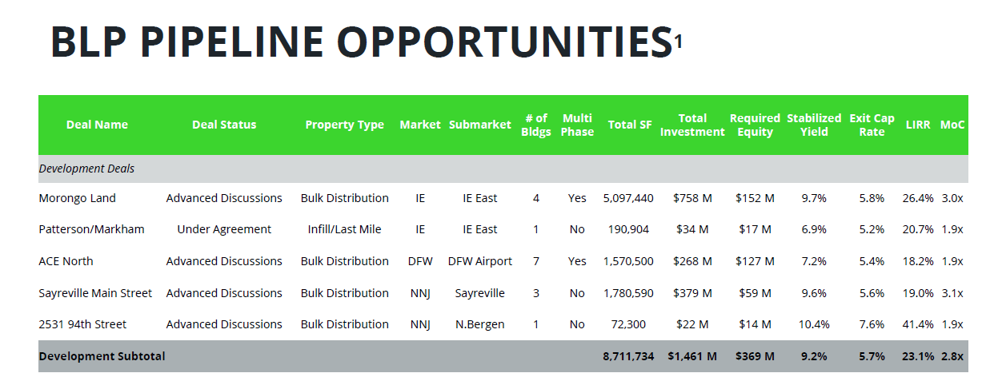

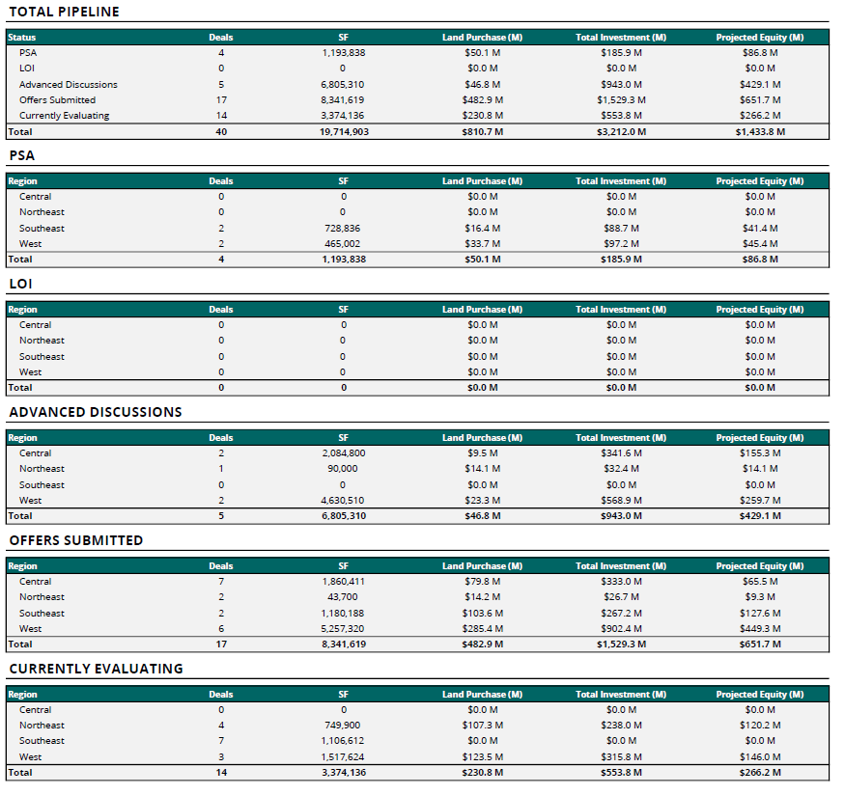

**EXHIBIT B: Bridge Investment Group Corporate Structure Chart**

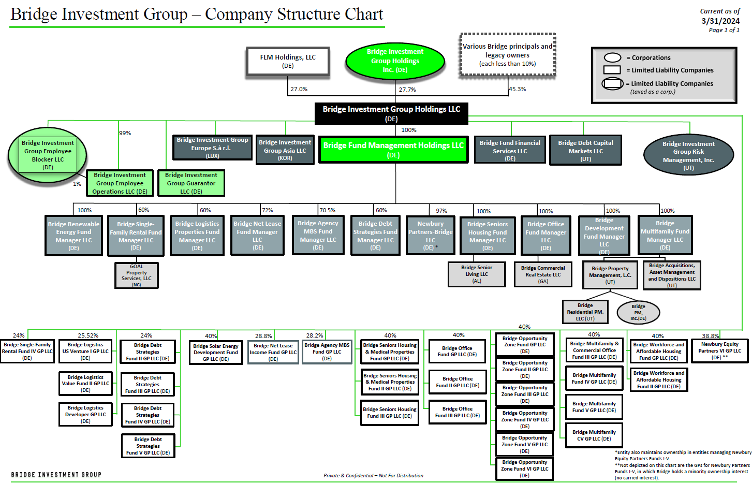

**EXHIBIT C: Bridge Investment Group Organizational Chart**

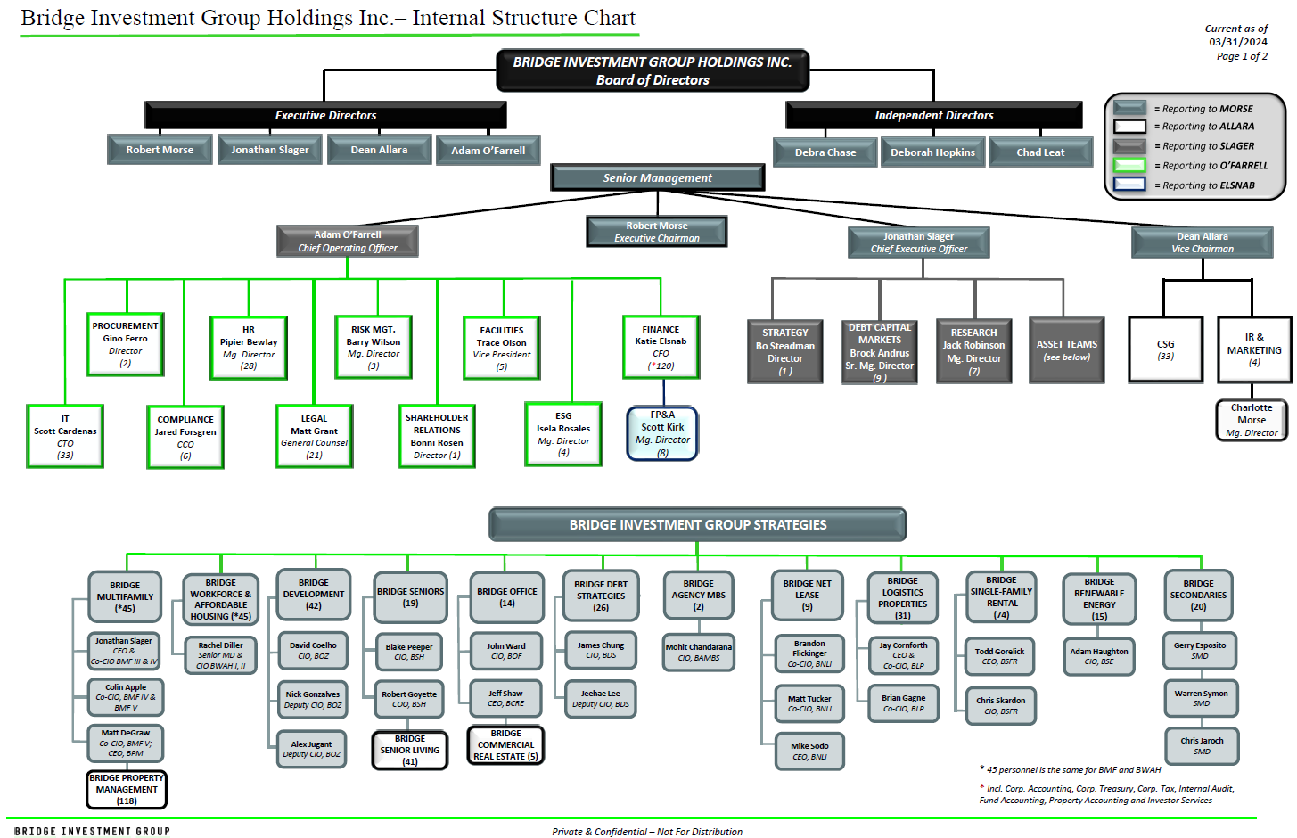

**EXHIBIT D: BLP Organizational Information (Org Chart)**

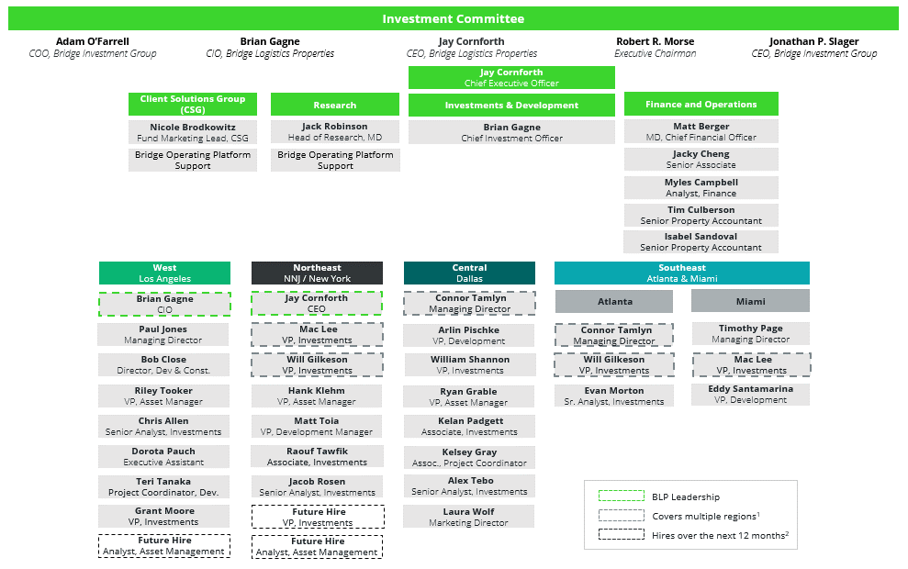

**EXHIBIT D: BLP Organizational Information (Role Definitions)**

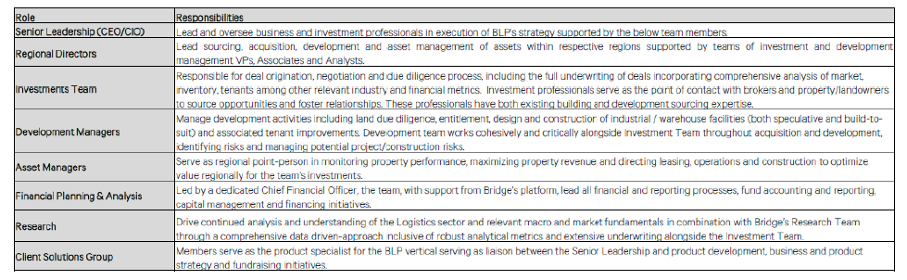

**EXHIBIT E: Senior Personnel Biographies**

**Jay Cornforth**, CEO

Jay Cornforth serves as Senior Managing Director & Chief Executive Officer, Co-Chief Investment Officer for Bridge Logistics Properties. For most of his career, Jay has focused on the industrial warehouse space and has over 25 years of experience. Over his career, Jay has directly invested or overseen $15 billion of deployment. Prior to joining Bridge, Jay was Managing Partner, Global Head of Logistics at Brookfield. At Brookfield, Jay oversaw Logistics investments in Brazil, Korea, China, and Western Europe, in addition to the USA. Jay was instrumental in launching Brookfield’s logistics platform and the acquisition, development, and management of 100 million square feet of logistics product. Between 2014 and 2016 during Brookfield’s ownership, Jay also dually served as CEO of IDI Logistics while he was Global Head of Logistics at Brookfield. Before his role at Brookfield, Jay was President, East Region at Prologis and worked at AMB from 2003 to 2011, prior to the AMB/Prologis merger. Jay began his career with Cabot Industrial Trust and its successor company Cabot Properties where he held national development duties. He also worked at AEW Capital Management in various roles in Portfolio Management and Investments. Jay grew up in Montreal, Canada and received a Bachelor of the Arts from the University of Western Ontario and a Master of Science in Real Estate Development at New York University.

**Brian Gagne**, CIO

Brian Gagne serves as Senior Managing Director & Co-Chief Investment Officer for Bridge Logistics Properties. Before joining Bridge, Brian worked at Brookfield to build out and lead the U.S. logistics investments team, where he oversaw both acquisition and development deployment from late 2017 to 2021. In that time, Brookfield grew their U.S. investment and development portfolio by 35 million square feet. Prior to leading the logistics investment team at Brookfield, Brian worked at IDI Logistics, a Brookfield-owned operating company, where he served as a Market Officer for the West Region. As Market Officer, Brian was responsible for all investments, asset management, and development activities. Brian was critical to the stabilization of the portfolio while also building AUM in California through existing building investments, spec development, and BTS transactions. Before joining Brookfield, Brian was at KTR Capital Partners, a private logistics platform founded by principals of Keystone Property Trust. Brian joined KTR shortly after their formation in 2005 and saw the company grow from 0 to 75 MSF over a decade. Brian was made partner and selected to open the company’s West Coast office and lead their investment efforts. KTR was primarily an East Coast focused entity and Brian successfully expanded the company’s footprint into the high barrier markets of Southern California, Bay Area and beyond. He acquired or developed over $2B of assets in the Western U.S. prior to the sale of the company in June 2015 to Prologis. Brian holds a Bachelor of Science in Business Administration from Babson College.

**Matt Berger**, Managing Director - Chief Financial Officer

Matthew Berger serves as Managing Director and Chief Financial Officer for Bridge Logistics Properties and brings over 25 years of finance experience to his role. Prior to joining Bridge, he served in a number of Senior roles with Brookfield Asset Management, most recently as Managing Director, Portfolio Management within Brookfield Property Group. Other key positions with Brookfield include Chief Financial Officer of IDI Logistics and Chief Financial Officer of Terraform Power, a publicly traded owner operator of renewable energy assets in North America and Europe. Prior to Brookfield, Matthew was Senior Vice President, Finance for Old Mutual Asset Management. He began his career in public accounting and consulting with PwC, earning his CPA. He holds a BBA in Accounting with honors from the University of Notre Dame and an MBA with honors from the Kenan Flagler Business School at UNC Chapel Hill.

**Paul Jones**, Managing Director - West Region

Paul Jones serves as a Managing Director for Bridge Logistics Properties. A recognized expert in the field of industrial real estate, Paul Jones has spent over 15 years perfecting his craft through complex transactions in some of the most competitive U.S. markets. Over the course of his career, Paul has invested $3 billion of capital through both existing building acquisitions and new developments. Prior to joining Bridge Investment Group, he was Head of Investments and Development for the Western United States at Brookfield Asset Management. In this role from 2019-2021, Paul established Brookfield’s Los Angeles Logistics office, built and led a team of professionals, oversaw operations, and grew the West region portfolio by 6.5 million square feet. Before his role at Brookfield, Paul was Vice President of Acquisitions in the Western U.S. for Duke Realty. From 2015-2019, he helped grow the company’s Southern California portfolio from approximately 1 million to 15 million square feet through existing building acquisitions and infill market redevelopment. Paul began his career with Studley, Inc., where he was an Investment Sales and Tenant Rep Broker. Notably, he is actively involved with Make-A-Wish Foundation, is a member of NAIOP’s Industrial Acquisitions Forum IV, has held multiple positions within NAIOP’s Young Professionals Group, and was awarded Real Estate Forum’s 50 Under 40 National Designation.

**Connor Tamlyn**, Managing Director Central Region

Connor Tamlyn serves as Managing Director, Central Region for Bridge Logistics Properties. Connor has over 12 years of commercial real estate experience and has directly facilitated transactions of more than 10M sf totaling over $1B in value. Before joining Bridge, Connor worked at Brookfield Properties Logistics as the development officer for the Central Region where he was responsible for sourcing and executing development opportunities in markets such as Dallas-Fort Worth, Houston, Austin, Chicago, Indianapolis, Cincinnati, Memphis and Nashville. While at Brookfield, he sourced development opportunities totaling 4M sf representing over $400M of total development value. Prior to joining Brookfield, Connor was a Director and Market Officer at Hines, one of the largest privately held real estate investment and development firms in the world. At Hines, he ran the industrial platform in Dallas-Fort Worth where he was responsible for the acquisition, development and asset management of industrial properties. While at Hines, Connor was responsible for adding over 3M sf to the firm's industrial portfolio. Connor holds a Bachelor of Business Administration, Real Estate from the University of Georgia.

**Tim Page**, Managing Director Southeast Region

Tim Page serves as Managing Director, Southern Region for Bridge Logistics Properties. Tim has over 35 years of commercial real estate experience. Before joining Bridge, he was President and CEO of Page Group Commercial Real Estate, Inc., a real estate development firm specializing in the development of industrial, office, hotel, and multi-family properties. Tim owned and operated Page Group for 21 years before retiring in 2020. Prior to establishing his own firm, he served as the Director of Operations for Stiles Realty Co. in South Florida from 1998 to 2000. While at Stiles, Tim was responsible for industrial, office building, and build-to-suit development opportunities. From 1994 to 1998, he was the Director of Development for Catalfumo Companies, responsible for all aspects of speculative development and build-to-suit activities ranging from site selection to disposition of assets.Tim began his career in 1986 as an industrial specialist in South Florida for CBRE Group, Inc. where he was a top performer throughout eight years at CBRE. He holds a Bachelor of Science in Finance from the Heavener School of Business in the Warrington College of Business at the University of Florida.

**EXHIBIT F: Project Approval Process**

BLP will regularly apprise CRF of potential opportunities within the mandate of the Partnership during the Commitment Period. BLP will establish a biweekly pipeline call with the CRF team to discuss potential opportunities in addition to operational updates (construction, leasing, financing, etc.). Upon request from CRF, BLP will provide an explanation and disclose reasonable information on any potential opportunities within the mandate that BLP did not recommend to CRF. BLP’s obligation to offer potential opportunities to the Partnership during the Commitment Period shall not apply to the Excluded Projects (defined below). BLP’s obligation to offer potential opportunities to the Partnership during the Commitment Period will lapse in the event that CRF shall reject three (3) or more potential projects within the mandate of the Partnership at any stage of the approval process within a consecutive twelve (12) month period.

There will be separate approval processes for pursuit and acquisition of the land (“Land Acquisition”) and the commencement of construction (“Construction Commencement”). In each case, BLP will provide a recommendation for CRF’s consideration and approval under the procedures set out below. In no event will CRF’s approval of the recommended transaction relieve BLP or Advisor of its Standard of Care or Fiduciary Duty.

1. Recommendation Notice and Investment Proposal

When a potential project is identified, BLP will send notice to CRF informing it of the potential project and recommending it for inclusion in the Partnership (the “Recommendation Notice”). The Recommendation Notice will include all material information reasonably needed by CRF to make an informed determination to opt in or opt out of each project (“Investment Proposal”). Without limiting the foregoing, the Investment Proposal will include all memoranda or other materials presented to BLP’s investment committee, which form the basis of BLP recommending the project to CRF.CRF would have the right to reject any Investment Proposal within 5 business days of receipt, and the Partnership would not invest in the proposed project or bear any pursuit costs or expenses.

1. Approved Project and Partnership Pursuit Costs

If CRF approves an Investment Proposal (“Approved Project”), BLP and CRF would be responsible for funding all due diligence expenses, pursuit costs, and refundable and non-refundable deposits (“Partnership Pursuit Costs”) based on a 50/50 cost-sharing ratio. Once a project becomes an Approved Project:

* 1. BLP would be reimbursed by the Partnership for 50% of actual Partnership Pursuit Costs incurred to date plus an amount such that BLP receives an 9% IRR on such costs;
  2. CRF would fund its 50% share of Partnership Pursuit Costs; and
  3. the Partners would remain responsible for funding Partnership Pursuit Costs going forward based on a 50/50 cost-sharing ratio.

Among other things, as part of the diligence process, BLP shall submit to CRF for approval a development budget and schedule, details on entitlements and respective timing, a stabilized operating budget, a narrative on the land acquisition, the construction process, market conditions, and lease-up plan, and summary of state and local taxes (and whether any exemptions are available given CRF is a government plan) (collectively and individually the “Initial Post-Closing Deliverables”).

1. Land Approval

Upon satisfactory completion of due diligence and finalized negotiations with the land seller, BLP would notify CRF of its intent to close on the land (“Recommendation to Close Land”), and Partnership Pursuit Costs would be trued up to Partnership Interests. CRF shall provide its approval or disapproval of the Recommendation to Close Land within 5 business days of receipt. The Recommendation to Close Land shall include, among other things:

1. any memoranda or other information provided to BLP’s investment committee based upon which the investment committee has made the final decision to proceed;
2. the agreed upon Initial Post-Closing Deliverables;
3. an update by BLP to CRF and the Partnership with regard to entitlements, including but not limited to the discretionary land use and density governmental approvals required to build the Approved Project, if applicable; and
4. a certification by BLP to CRF and the Partnership that:
5. the Approved Project meets a minimum gross IRR of 9% over the Initial Term,
6. the un-trended ROC presented in the Investment Proposal has not been negatively impacted by more than 0.50%, and
7. there have been no identified potential construction delays of more than six (6) months.

In the event BLP cannot provide the certificate described in subsection 3(d) above, it would be a “Material Change” and CRF may terminate the Approved Project and Partnership Pursuit Costs would be funded by the Partnership based on the Partners’ 50/50 cost-sharing ratio.

1. Construction Approval

If the Approved Project continues to be suitable for investment by the Partnership after Land Acquisition, BLP shall submit to CRF a written recommendation to commence construction on the Approved Project (a “Recommendation to Commence Construction”) at least thirty (30) days prior to the scheduled date of Construction Commencement. The Recommendation to Commence Construction shall include:

1. a draft Guaranteed Maximum Price Contract (“GMAX Contract”), including a summary of all key terms;
2. indicative construction financing terms;
3. updated project plans; and
4. a certification by BLP to CRF and the Partnership that:
5. the land closing has occurred,
6. BLP’s investment committee has approved acquisition and development of the Approved Project in accordance with the materials provided to CRF,
7. except to the extent otherwise provided in the Recommendation to Commence Construction, there has not been a Material Change, or changes in the structure of the transaction, economics (current or projected), or physical condition of the Approved Project, and
8. except to the extent otherwise provided in the Recommendation to Commence Construction, the information contained in and disclosed by the Recommendation to Close Land, the investment materials provided remain true, complete and correct as of the date of the Recommendation to Commence Construction.

CRF shall advise BLP within this thirty (30) day period whether it approves proceeding with the Approved Project (the “Construction Approval”). CRF’s failure to issue a Construction Approval shall be deemed to be a disapproval of the Approved Project proceeding.

CRF will have sole discretion to terminate its participation at any time prior to the issuance of the Construction Approval. In the event CRF terminates the Approved Project as provided in this Section, CRF will reimburse BLP for 100% of Land Acquisition and Partnership Pursuit Costs for such formerly Approved Project. BLP shall have the right to pursue such formerly Approved Project with another partner for six (6) months of CRF’s decision not to pursue. In such an event, BLP shall reimburse CRF for the Land Acquisition and Partnership Pursuit Costs within thirty (30) days of the closing of the transfer of the Approved Project out of the Partnership. In the event BLP does not proceed with another partner, the formerly Approved Project would be sold and the available proceeds would reimburse CRF (with any excess proceeds being allocated 50/50 among the Partners).

**EXHIBIT G: Affiliate Fees**

**Services and Fees**

BLP would manage the day-to-day operations of the Partnership and as Development Manager, Construction Manager, and Asset Manager as outlined below:

Development Manager. BLP would be responsible for all pre-development and development work, including due diligence, financial analysis, contract negotiation, including securing a GMAX Contract for construction of the Approved Project (subject to approval by CRF), and administration, site planning, and coordination of architecture and design services. BLP would earn a Development Fee of 4% of budgeted hard and managed soft costs, excluding land, construction loan interest reserve and the fee itself.

One-third of the Development Fee would be paid upon closing of the construction loan. Two-thirds of the Development Fee would be paid monthly pro rata during construction (not to overlap with the Investment Management Fee).

Construction Manager. Beginning upon issuance of the Certificate of Occupancy, BLP would serve as the Construction Manager for any capital improvements at an Approved Project (including, but not limited to, repairs outside the ordinary course, renovations, refurbishments, or other enhancements). BLP would earn a Construction Management Fee equal to 5.0% for budget amounts up to $200,000, 4.0% for budget amounts above $200,000 up to $500,000, and 3.0% for budget amounts greater than $500,000.

Asset Manager. BLP, or an affiliate of Bridge, would be responsible for providing asset management services to the Partnership. BLP would earn an annual Investment Management Fee equal to 0.35% on Gross Asset Value, beginning upon issuance of the Certificate of Occupancy through Initial Term. Separate agreements to be negotiated as to leasing and property management, both terminable upon notice from CRF.

**Covered Cost Overruns**

In relation to the final budget within the GMAX Contract, controllable (i.e., not resulting from lender/CRF failure to fund, emergencies, design deficiencies, etc.) cost overruns not covered by the contractors and/or its bonds, insurance or applicable cost savings and contingencies (“Covered Cost Overruns”) would be funded 100% by BLP up to an amount equal to 50% of BLP’s Development Fee for the applicable project, and thereafter by the Partners pro rata in accordance with Partnership Interests.

The Covered Cost Overruns would exclude, among other things, tenant improvement costs, post-completion expenses, change orders approved by both Partners or that are required under applicable law or construction loan documents, construction interest, costs resulting from force majeure in the construction contract, operating expenses, permit fees, insurance premiums and real estate taxes paid during construction.

**EXHIBIT H: Strategy Allocations Guidelines**

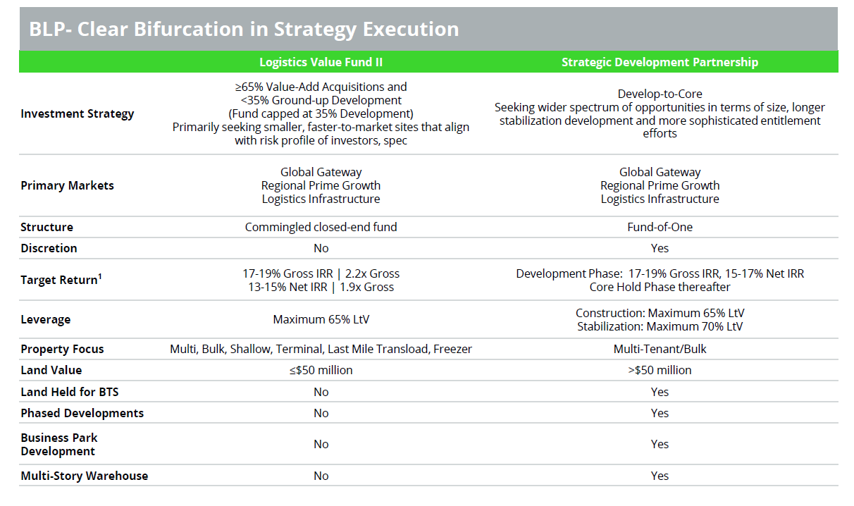

**EXHIBIT I: Value Fund I Asset Management Summary**

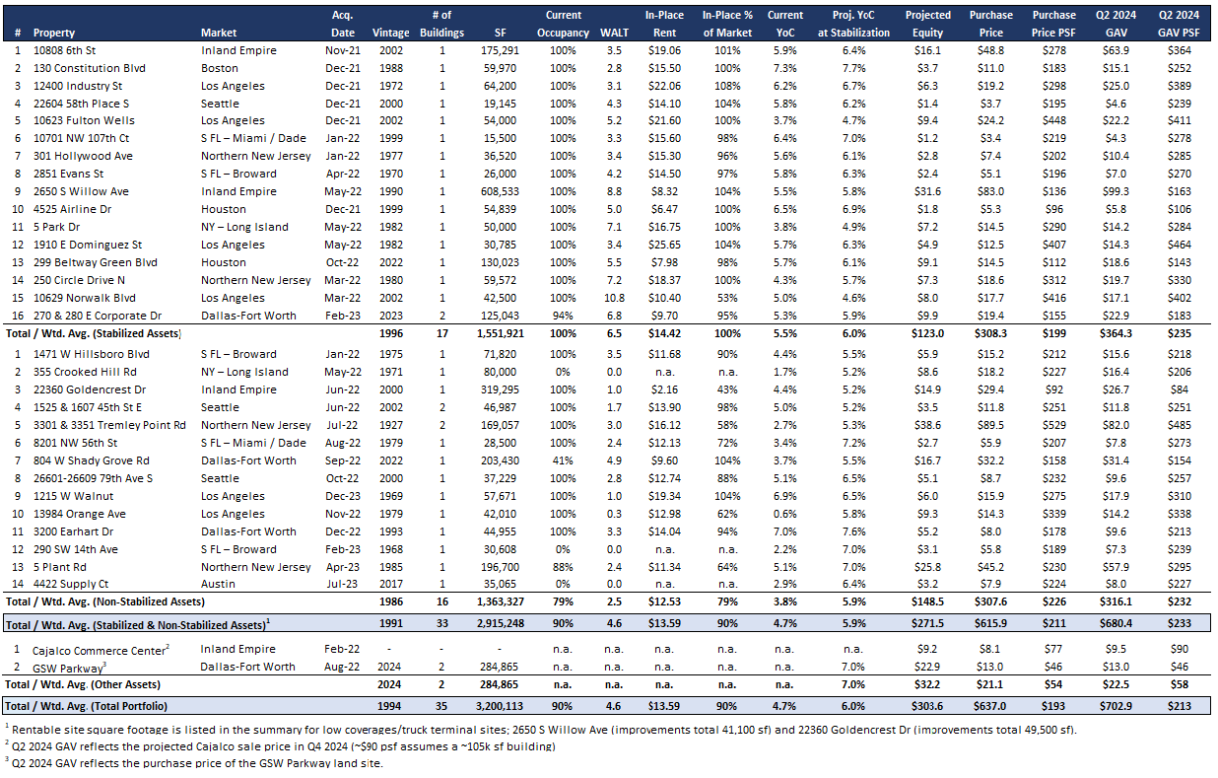

**EXHIBIT I: Value Fund I Asset Management Summary**

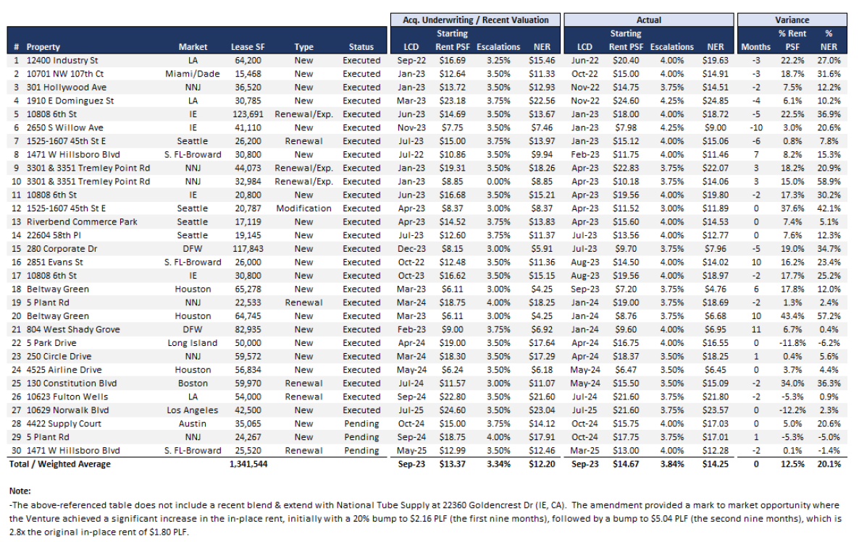

**EXHIBIT J: Deal-by-Deal Performance Detail**



**EXHIBIT K: BLP Development Transactions**

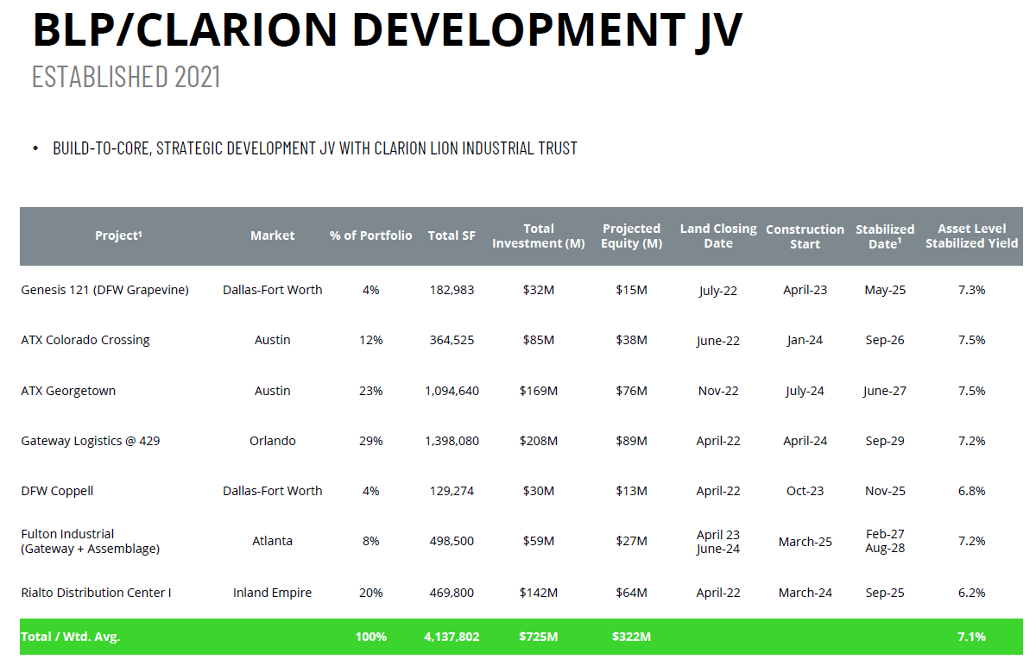

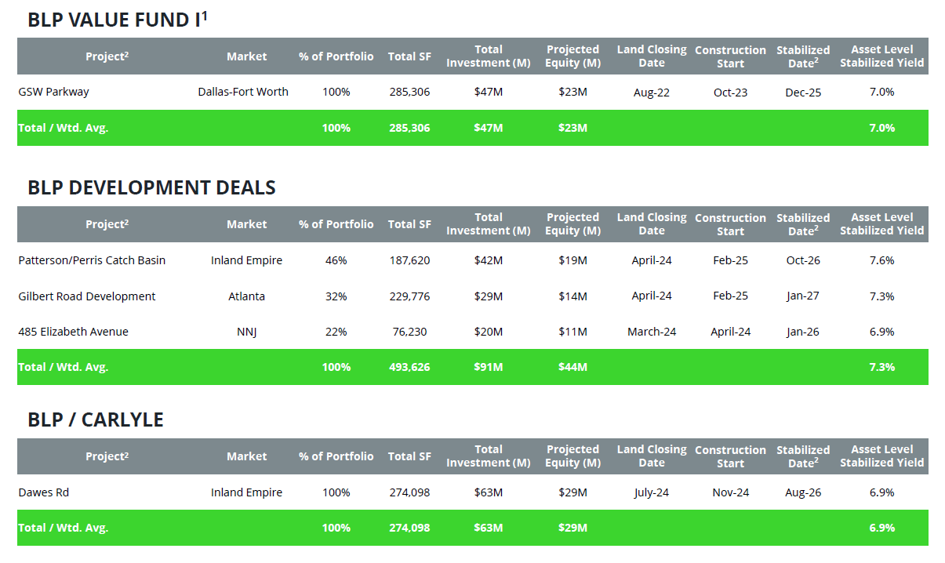

**Appendix**

**Rating Rationale**

|  |  |
| --- | --- |
| *ESG Policy & Practices* | *Integrated* as described in the ESG section of this report. |
| *Fund Structure* | Customized to fit NYSCRF and provides enhanced discretion and oversight. |
| *Investment Process* | Manager generally follows a standard institutional process across its vertically integrated platform. This Fund overlays certain communication and decision-making processes specific to a CRF fund-of-one. Townsend generally views the proposed process as standard for vehicles of this kind. |
| *Operational Due Diligence* | Rated A2 Pass (✓) in 2021 review conducted for BLP’s flagship Value fund. |
| *Performance* | Limited given the early stages of both the Sponsor and its initial fund launch. |
| *Sponsor* | Experienced staff with sufficient resources from platform build-out since launch in 2021 overlayed with a degree of oversight and operational support from a well-established multi-platform real estate specialist in Bridge Investment Group. |
| *Strategy* | Opportunistic risk-return profile focused on larger developments where traditional finite-life closed-end fund capital would be less appropriate. Industrial sector remains a thematic focus. |
| *Terms & Conditions* | Favorable relative to closed-end fund alternatives, reflecting NYSCRF’s significant capital commitment. |
| *Overall* | The Fund is not broadly marketed and has been Buy-rated as a Fund-of-One opportunity specific to NYSCRF. |

**Investment Rating Explanation**

The comments and assertions reflect Townsend views of the specific investment product, its strengths and weaknesses in general and in the context of Townsend’s *View of the World* and same vintage alternative choices.

* **Buy** - Suitable for institutional investors that have a portfolio construction need. Appropriate overall risk profile given the strategy and targeted returns.
* **Qualified** - Suitable for institutional capital. In addition to customary risks, contains one or more heightened risks that should be weighed against an investor’s preferences, risk tolerances, and portfolio construction needs.

Operational due diligence rating provided by Aon’s dedicated multi-asset class Operational Due Diligence team according to its autonomous review of the Sponsor’s policies & procedures, infrastructure and capabilities across a range of operations, middle and back office, and control functions.

* **A1-Pass** – (✓+) No material operational concerns; firm’s operations largely align with a well-controlled operating environment.
* **A2-Pass (**✓) - Firm’s operations largely align with a well-controlled operating environment, with limited exceptions due to resource limitations or where isolated areas do not align with best practice.
* **Conditional Pass** - Aon noted specific operational concerns that the firm has agreed to address in a reasonable timeframe.

ESG scoring and an associated rating is according to guidance from Townsend’s internal ESG Committee.

* **Limited** - The fund management team takes limited steps to address ESG considerations in existing and anticipated portfolios.
* **Integrated** - The fund management team takes essential steps to identify, evaluate, and mitigate potential financially material ESG risks within existing and anticipated portfolios.
* **Advanced** - The fund management team demonstrates an advanced awareness of potential ESG risks in the investment strategy. The fund management team can demonstrate advanced processes to identify, evaluate, and potentially mitigate these risks across its activities.

**About The Townsend Group**

Founded in 1983, Townsend Group, (“Townsend”) provides a core set of investment skills exclusively focused on global real estate and real asset classes. The firm offers these capabilities to institutional investors as an investment advisor and consultant.

Townsend has been advising and managing real estate portfolios for over three decades and across multiple market cycles. As of December 31, 2023, Townsend had assets under management of approximately $21.5 billion. As of December 31, 2023, Townsend provided advisory services to clients who had real estate/real asset allocations exceeding $218.2 billion. We believe, through our global investment platform, fiduciary culture, asset class expertise and client capital scale, we are able to deliver clients unique information, while providing a sourcing and execution advantage.

*Disclaimer*

This document has been prepared by Townsend Holdings LLC (“Townsend”) and is appropriate solely for qualified investors. Nothing in this document should be treated as an authoritative statement of the law on any particular aspect or in any specific case. It should not be taken as financial advice and action should not be taken as a result of this document alone. The information contained herein is given as of the date hereof and does not purport to give information as of any other date. The delivery at any time shall not, under any circumstances, create any implication that there has been a change in the information set forth herein since the date hereof or any obligation to update or provide amendments hereto. The information contained herein is derived from proprietary and non-proprietary sources deemed by Townsend to be reliable and are not necessarily all inclusive. Reliance upon information in this material is at the sole discretion of the reader. This document does not constitute an offer of securities or solicitation of any kind and may not be treated as such, i) in any jurisdiction where such an offer or solicitation is against the law; ii) to anyone to whom it is unlawful to make such an offer or solicitation; or iii) if the person making the offer or solicitation is not qualified to do so. Townsend is a Registered Investment Adviser with the Securities and Exchange Commission. Select Townsend employees may have personal interest in this investment/fund or affiliates of this investment/fund. All Townsend employees are subject to an investment pre-clearance process for such investments under Townsend's Code of Ethics. To assess any conflict of interest/perceived conflict of interest and to avoid any opportunity of beneficial treatment, all employee investments that may create a conflict/or perceived conflict are monitored by Townsend Compliance and the Townsend Compliance Committee.

1. The Covered Cost Overruns would exclude, among other things, tenant improvement costs, post-completion expenses, change orders approved by both Partners or that are required under applicable law or construction loan documents, construction interest, costs resulting from force majeure in the construction contract, operating expenses, permit fees, insurance premiums and real estate taxes paid during construction.
2. The Manager’s generic fund model assumes a 23.3% development gross IRR on a $118 million total cost basis deal generates $4.79 million of promote; a 50% LTV refi generates $6.1M of cash proceeds of which $2.4M would fund the cash incentive.
3. The use of non-recourse financing is identified in the draft term sheet definitively, rather than stated as an expected best practice. It is expected this will be formalized in the Fund’s final operating documents.
4. While the fund’s formal limitation is 35%, Bridge has preferred to operate the fund at closer to 20% development exposure.
5. Includes Jay Cornforth, Brian Gagne, Matt Berger, and a representative from the Bridge Investment Group finance team.